iDOCTOR MEDICAL SYSTEM
Author: Prof (Mrs.) Kriti Srivastava, Akash Sonetha, Viraj Shah, Jay Shah
kriti.srivastava@djsce.ac.in, akash.sonetha@gmail.com, virajshah.77@gmail.com, s.jay93@gmail.com

Abstract-: In today’s world where technology has progressed with the lightening speed there is a need to create an electronic health platform, delivering 360-degree health services and products. In this paper, we present the idea to provide a health service, which is just a click away of a button. It includes measurement of various vital parameters, preparation of digital reports, sending reports to the doctor via e-mail or SMS, providing remedies as suggested by doctors, taking an appointment with doctor if needed and generating a doctor visit prep sheet. In this jet age, these services are specially designed for convenience and safety. And all of this can be done by you at you home all by yourself

I. Introduction
Healthcare is a multimillion-dollar industry and a vital service within society. Easily accessible medical services and early treatment are the need of the hour. Advancement in the technology in the recent years has been marked tremendous. Devices became smaller, faster, portable and more powerful. Broadband networks have reached out and connected most major cities providing an effective base to launch communication-based services that were not feasible before. This paper proposes a system, which is designed with information technology, collaborated with medical services. This system provides medical assistance to the patients through the website, ensures medical service when patient requires. It provides an electronic platform for the patient-doctor communication. With the progress of computers and networking at present, this system establishes a base for an electronic health service to the people at their doorstep.
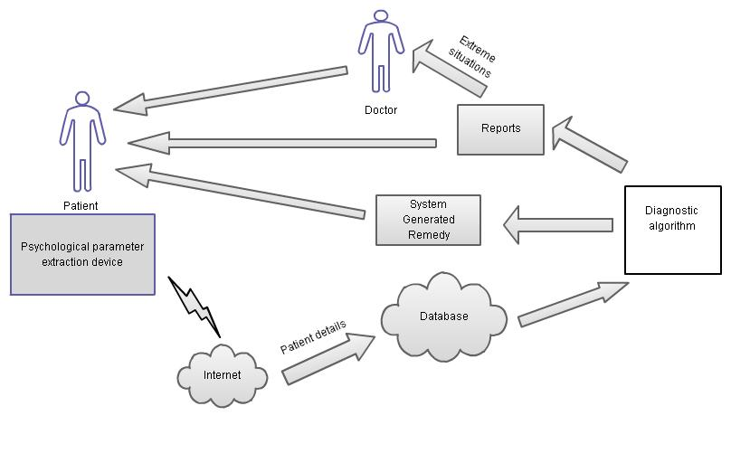
Figure 1: Workflow

II. BLOCK DIAGRAM OF OUR MEDICAL SUPPORTING SYSTEM

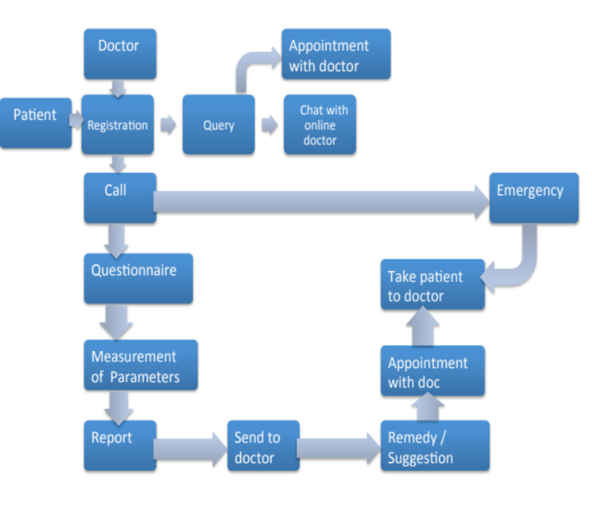
Figure 2: Complete Block Diagram

The objective is to design a complete medical supporting system, which intends to cover the following aspects:
- Registration of patient with his complete medical history.
- Registration of doctor with his details.
- Website services for general remedial suggestions, digital communication with doctors and accessing information about available doctors in the vicinity.
- Doctor visit prep sheet with current readings.
For availing the medical services the patient should register with the system through the website. It registers patients’ complete information, which includes the basic information of the patient such as name, address, mobile number etc., demographic information, medical history, also any major or minor illness, allergies, operative history if any etc. When needed, patient can visit the website using his email and password to measure his or her vitals. Ex. Temperature and blood pressure.

The digital report showing patients’ current condition is generated and is send to the doctor for diagnosis. If asked by the doctor, medical history will be provided. Depending on the doctors’ diagnosis and advice, remedies are suggested. The patients can also avail the facility of asking the queries to the doctors on the website. This system will be a boon for the people living alone or with old age or in case of emergency.

III. MEASUREMENT OF ESSENTIAL PARAMETER

The parameters to be measured which include body temperature; the output of the sensor goes through amplifier and filter circuit and after signal conditioning it’s given for digitization and the value is then directly interfaced on the web page via USB connector. Other parameter is blood pressure the output from the digital blood pressure is fed into the laptop via USB, similarly the oximeter. Output from the probe is connected to the USB connector and is fed into the computer /laptop. After all the essential parameters are measured a report of the patient is generated.

- Temperature

The digital temperature sensor, DS18B20 provides calibrated digital temperature readings directly and precisely without complicated calculation in code. It measures temperatures from -55°C to +125°C (-67°F to +257°F) with ± 0.5°C accuracy from -10°C to +85°C. The tip of the sensor is placed in the patient’s armpit for a minute. The 3 pins of the sensor i.e. Vcc, Data pin, GND are connected to a DS18B20 electronic brick connector. The data pin is connected to pin no. 2 of the Arduino Uno R2. The USB cable is then connected to the board. Using the Arduino IDE, the program code is uploaded on the arduino board. The temperature is converted into a digital value using the code uploaded and fed into the PC using the USB cable. The temperature can then be read on the computer monitor.

- Oximeter

Pulse oximeter needs two different wavelengths (660 and 940 nm), which is multiplexed by GPIO (analog multiplexer). The intensity of the wavelength is controlled by PWM signal .Now to drive the LED circuit a driver circuit is implemented to provide sufficient energy to work. The pulse oximeter sensors used are the DS100 series sensors .The output of the photodiode is a current, which is converted into voltage by I to V converter for filtering purpose. The red and infrared signal then passes through the filtering and amplification block .It consist of active and passive filter for signal processing and noise elimination. A voltage reference generator is used for mounting the analog signal on positive dc typically (VCC/2). Now the signal is digitalized by ADC and is then fed to computer/laptop via USB connector.

3. Blood Pressure

This monitoring system is a Pulse Transit Time method to measure blood pressure. A pressure cuff and pump, along with the transducer, are used to measure blood pressure and heart rate in 3 phases, inflation, measurement, and deflation. Also included is a USB interface. The core subsystem includes processor/memory-Digital pressure measurement and heart rate is performed by the microcontroller. Measurement results are stored in Flash memory as a data log that can be uploaded to a computer via USB. Sensor Interface - Allows the processor to control the cuff inflation/deflation and sense blood pressure that is amplified by instrumentation amplifiers and digitalized by ADC.

IV. DESIGNING OF WEBSITE

For patients to access our medical system they have to register themselves on the website named ‘www.idoctormedical.in’.

This is the registration webpage where the patient needs to register before using the facilities of the webpage. The registration is divided into two pages. The first page requires you to fill in the general details about yourself. On the second page you need to fill all your medical history by filling a questionnaire.

This is the login page where the patient can login after registering using username and password, where he can access his account and contact the required doctor or other facilities for help.

This is the page wherein the patient can map down the near-by doctor or hospital (In case of emergency).According to the pin code of the area the following area becomes the centre point on the Google map and all the nearby hospital are named down at the side of the map.

V. CONCLUSION:

The concept of measuring patient parameters with the help of a call service is one of its first kinds in the country. The aim is to provide service to the people who don’t have a family or are in the state of an emergency. Depending upon the number and the location of the registered members, the service can be made available in different parts of the country. In an age where work is the top most priority for an individual, such a system would help in looking after the health of an individual and taking care of his well being.

VI. REFERENCE:

- Jeonggil Ko; Tia Gao; Richard Rothman; Andreas Terzis; Wireless Sensing Systems in Clinical Environment, IEEE Engineering in Medicine and Biology Magazine, Issue : March/April 2010.

- UpkarVarshney, Managing Wireless Health Monitoring for Patients with Disabilities, IT Pro , Issue : November/December 2006.

- Ren-Guey Lee, Kuei-ChienChen, Chun-ChiehHsiao and Chwan-LuTseng,”A Mobile Care System with Alert Mechanism”, IEEE Transactions on Information Technology in Biomedicine, Vol. 11, No-5, Issue: September 2007.

- “Temperature Sensor DS18B20”,http://arduino-info.wikispaces.com/Brick-Temperature-DS18B20, July 2012.

- “How it works DS18B20 and Arduino”,http://tushev.org/articles/electronics/42-how-it-works-ds18b20-and-arduino, June 2012.

- Ania Monaco, “A view inside the Cloud”, http://theinstitute.ieee.org/technology-focus/technology-topic/a-view-inside-the-cloud,June 2012.

- Patrick S Ryan, Ronak Merchant and Sarah Falvey, “Regulation of Cloud in India”, Journal of Internet Law, Vol. 15, No. 4, p. 7, October 2011.

- Daniele Cattedu and Giles Hobben, “Cloud Computing recommendation for information security”, http://www.enisa.europa.eu/activities/risk-management/files/deliverables/cloud-computing-risk-assessment, November 2009

